Fixed-point Arithmetic Lab
Student ID _____________________
Student Name _____________________
Start Time ________________________
Finish Time ________________________

- Fixedpoint lab
Follow the instruction Fixed-point arithmetic-lab.pdf . Write down your source code and show your screenshot of testing result. s

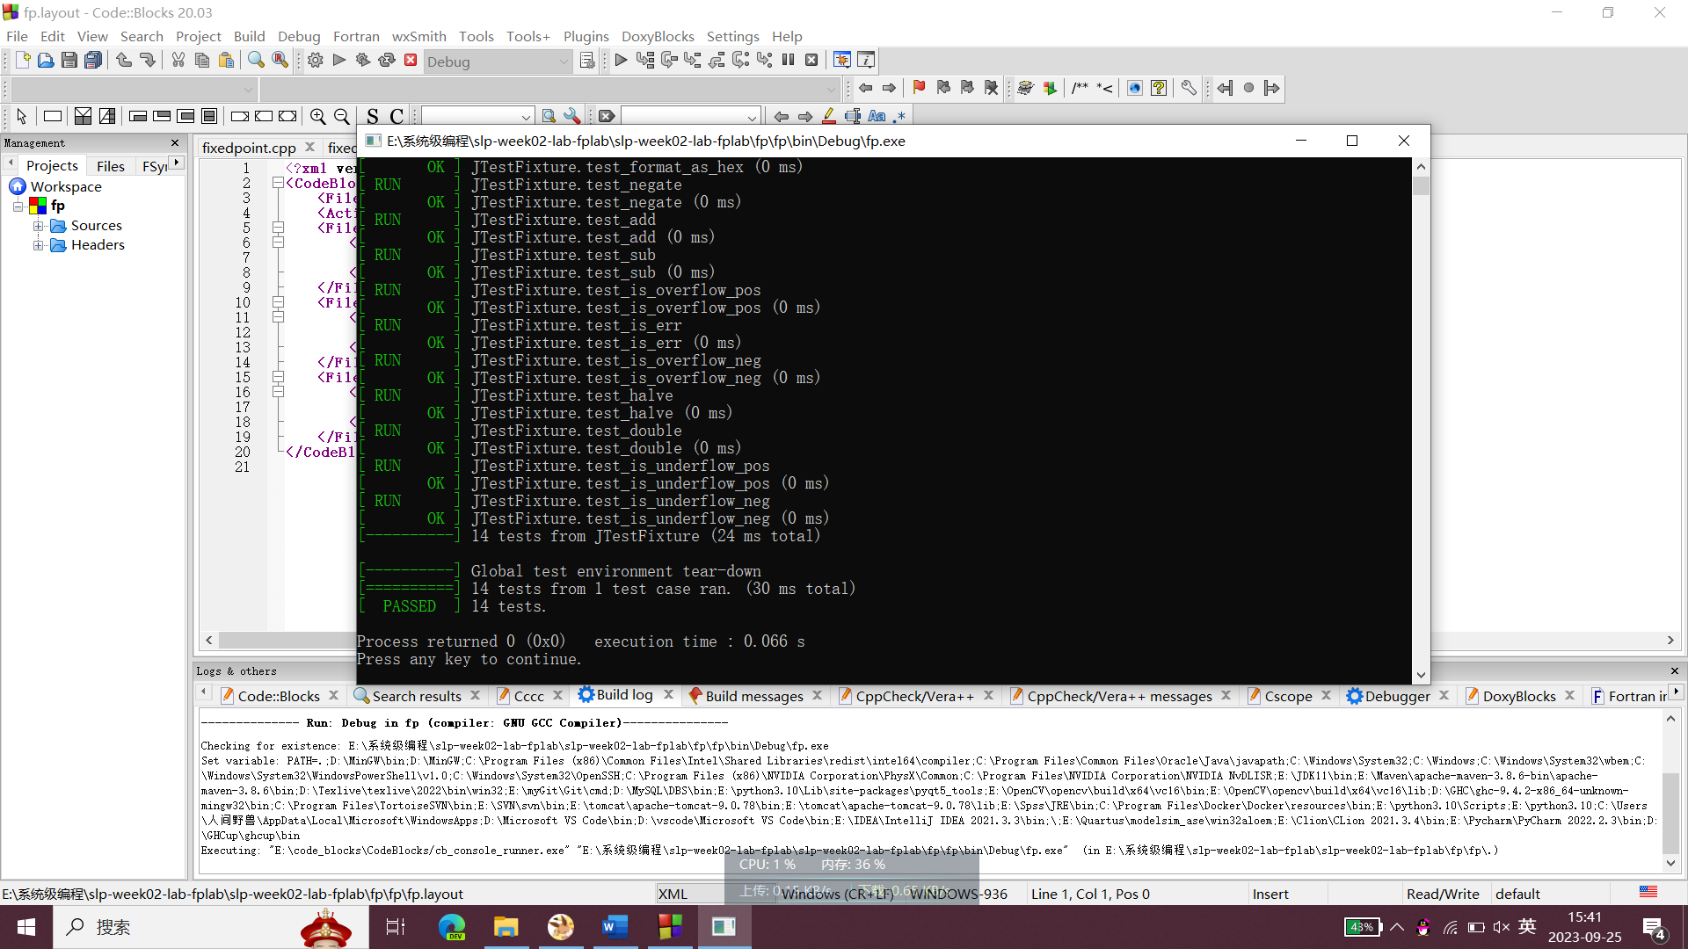

#include <stdio.h>
#include <stdlib.h>
#include <string.h>
#include <ctype.h>
#include <assert.h>
#include "fixedpoint.h"

// You can remove this once all of the functions are fully implemented
static Fixedpoint DUMMY;

Fixedpoint fixedpoint_create(uint64_t whole) {

// TODO: implement
Fixedpoint fp;
fp.whole=whole;
fp.frac=0;
fp.flag=0;
return fp;
}

Fixedpoint fixedpoint_create2(uint64_t whole, uint64_t frac) {
// TODO: implement
Fixedpoint fp;
fp.whole=whole;
fp.frac=frac;
fp.flag=0;

return fp;
}

Fixedpoint fixedpoint_create_from_hex(const char *hex) {
// TODO: implement
Fixedpoint fp;
fp.whole=0;
fp.frac=0;
fp.flag=0;
int i=0;
int tflag=0;
int whole_len=0;
int frac_len=0;

if(hex[0]=='-'){
fp.flag=1;
i++;
}
for(;hex[i]!='\0';i++){
if(hex[i]=='.'){
tflag=1;
continue;
}
if(tflag==0){
fp.whole=fp.whole<<4;
if(hex[i]>='0'&&hex[i]<='9'){
fp.whole+=hex[i]-'0';
}
else if(hex[i]>='a'&&hex[i]<='f'){
fp.whole+=hex[i]-'a'+10;
}
else if(hex[i]>='A'&&hex[i]<='F'){
fp.whole+=hex[i]-'A'+10;
}
else{
fp.flag=2;
}
whole_len++;
}
else{
fp.frac=fp.frac<<4;
if(hex[i]>='0'&&hex[i]<='9'){
fp.frac+=hex[i]-'0';
}
else if(hex[i]>='a'&&hex[i]<='f'){
fp.frac+=hex[i]-'a'+10;
}
else if(hex[i]>='A'&&hex[i]<='F'){
fp.frac+=hex[i]-'A'+10;
}
else{
fp.flag=2;
}
frac_len++;
}
}

if(whole_len>16||frac_len>16){
fp.flag=2;
}
else{
fp.frac=fp.frac<<(4*(16-frac_len));
}

return fp;
}

uint64_t fixedpoint_whole_part(Fixedpoint val) {

// TODO: implement
return val.whole;
}

uint64_t fixedpoint_frac_part(Fixedpoint val) {

// TODO: implement
Fixedpoint fp;
fp=val;

return fp.frac;
}

Fixedpoint fixedpoint_add(Fixedpoint left, Fixedpoint right) {

// TODO: implement
Fixedpoint fp;
int lpreflag=left.flag;
int rpreflag=right.flag;
if(left.flag==1){
left.whole=~left.whole;
if(~left.frac>~left.frac+1){
left.frac=~left.frac+1;
left.whole++;
}
else{
left.frac=~left.frac+1;
}
}
if(right.flag==1){
right.whole=~right.whole;
if(~right.frac>~right.frac+1){
right.frac=~right.frac+1;
right.whole++;
}
else{
right.frac=~right.frac+1;
}
}

fp.whole=left.whole+right.whole;
fp.frac=left.frac+right.frac;
//判断是否进位，进位后的小数部分比原来小
if((fp.frac<left.frac)||(fp.frac<right.frac)){
fp.whole++;
}

//符号相同判断是否溢出
if(left.flag==right.flag){
if(left.flag==0){
if((fp.whole>>63!=left.whole>>63)||(fp.whole>>63!=right.whole>>63)){
fp.flag=4;
}
else{
fp.flag=0;
}
}

else{
if((fp.whole>>63!=left.whole>>63)||(fp.whole>>63!=right.whole>>63)){
fp.flag=7;
}
else{
fp.flag=1;
}
}
}

//符号不同需判断正负
else{
if(left.flag==1){
left.whole=~left.whole;
if(~left.frac>~left.frac+1){
left.frac=~left.frac+1;
left.whole++;
}
else{
left.frac=~left.frac+1;
}

left=fixedpoint_negate(left);

}

if(right.flag==1){
right.whole=~right.whole;
if(~right.frac>~right.frac+1){
right.frac=~right.frac+1;
right.whole++;
}
else{
right.frac=~right.frac+1;
}

right=fixedpoint_negate(right);

}

//比较大小
if(fixedpoint_compare(left, right)==1){
fp.flag=lpreflag;
}

else if(fixedpoint_compare(left, right)==0){
fp.flag=0;
}

else{
fp.flag=rpreflag;
}

}

if(fp.flag==1||fp.flag==5||fp.flag==7){
fp.whole=~fp.whole;
if(~fp.frac>~fp.frac+1){
fp.frac=~fp.frac+1;
fp.whole++;
}
else{
fp.frac=~fp.frac+1;
}
}

return fp;
}

Fixedpoint fixedpoint_sub(Fixedpoint left, Fixedpoint right) {

// TODO: implement
Fixedpoint fp;

//负数取反加一
int lpreflag=left.flag;
int rpreflag=right.flag;
if(left.flag==1){
left.whole=~left.whole;
if(~left.frac>~left.frac+1){
left.frac=~left.frac+1;
left.whole++;
}
else{
left.frac=~left.frac+1;
}
}
if(right.flag==1){
right.whole=~right.whole;
if(~right.frac>~right.frac+1){
right.frac=~right.frac+1;
right.whole++;
}
else{
right.frac=~right.frac+1;
}
}

//被减数取反加一
right.whole=~right.whole;
if(~right.frac>~right.frac+1){
right.frac=~right.frac+1;
right.whole++;
}

else{
right.frac=~right.frac+1;
}

right=fixedpoint_negate(right);

fp.whole=left.whole+right.whole;
fp.frac=left.frac+right.frac;

//判断是否进位，进位后小数部分比原来小
if((fp.frac<left.frac)||(fp.frac<right.frac)){
fp.whole++;
}

//判断是否溢出
if(lpreflag!=rpreflag){
if(lpreflag==0){
if((fp.whole>>63!=left.whole>>63)||(fp.whole>>63!=right.whole>>63)){
fp.flag=4;
}
else{
fp.flag=0;
}
}

else{
if((fp.whole>>63!=left.whole>>63)||(fp.whole>>63!=right.whole>>63)){
fp.flag=7;
}
else{
fp.flag=1;
}
}
}

//符号位一样需判断正负
else{
right.whole=~right.whole;
if(~right.frac>~right.frac+1){
right.frac=~right.frac+1;
right.whole++;
}

else{
right.frac=~right.frac+1;
}

right=fixedpoint_negate(right);

if(fixedpoint_compare(left, right)==1){
fp.flag=0;
}

else if(fixedpoint_compare(left, right)==0){
fp.flag=0;
}

else{
fp.flag=1;
}

}

//结果为负数则取反加一
if(fp.flag==1||fp.flag==5||fp.flag==7){
fp.whole=~fp.whole;
if(~fp.frac>~fp.frac+1){
fp.frac=~fp.frac+1;
fp.whole++;
}
else{
fp.frac=~fp.frac+1;
}
}

return fp;
}

Fixedpoint fixedpoint_negate(Fixedpoint val) {

// TODO: implement
if(val.flag==0&&(!fixedpoint_is_zero(val))){
val.flag=1;
}

else{
val.flag=0;
}
return val;
}

Fixedpoint fixedpoint_halve(Fixedpoint val) {
// TODO: implement
Fixedpoint fp;
fp.flag=val.flag;
if(val.flag==0){
if(val.frac&0x0000000000000001UL==1){
fp.flag=6;
}

if(val.whole&1==1){
fp.frac=val.frac>>1;
fp.whole=val.whole>>1;
fp.frac+=0x8000000000000000UL;
}
else{
fp.frac=val.frac>>1;
fp.whole=val.whole>>1;
}
}
else{
//负数先取反再加一
val.whole=~val.whole;
if(~val.frac>~val.frac+1){
val.frac=~val.frac+1;
val.whole++;
}
else{
val.frac=~val.frac+1;
}

if(val.frac&0x0000000000000001UL==1){
fp.flag=5;
}
if(val.whole&1==1){
fp.frac=val.frac>>1;
fp.whole=val.whole>>1;
fp.frac+=0x8000000000000000UL;
}
else{
fp.frac=val.frac>>1;
fp.whole=val.whole>>1;

}
//再取反加一
fp.whole=~fp.whole;
if(~fp.frac>~fp.frac+1){
fp.frac=~fp.frac+1;
fp.whole++;
}
else{
fp.frac=~fp.frac+1;
}
}

return fp;

}

Fixedpoint fixedpoint_double(Fixedpoint val) {
// TODO: implement
Fixedpoint fp;
fp.flag=val.flag;
if(val.flag==0){
if(val.whole&0x8000000000000000UL==1){
fp.flag=4;
}

if((val.frac>>63)&1==1){
fp.whole=val.whole<<1;
fp.frac=val.frac<<1;
fp.whole+=0x0000000000000001UL;
}
else{
fp.whole=val.whole<<1;
fp.frac=val.frac<<1;
}
}
else{
//负数先取反再加一
val.whole=~val.whole;
if(~val.frac>~val.frac+1){
val.frac=~val.frac+1;
val.whole++;
}
else{
val.frac=~val.frac+1;
}

if(val.whole&0x8000000000000000UL==1){
fp.flag=7;
}

if((val.frac>>63)&1==1){
fp.whole=val.whole<<1;
fp.frac=val.frac<<1;
fp.whole+=0x0000000000000001UL;
}
else{
fp.whole=val.whole<<1;
fp.frac=val.frac<<1;
}
//再取反加一
fp.whole=~fp.whole;
if(~fp.frac>~fp.frac+1){
fp.frac=~fp.frac+1;
fp.whole++;
}
else{
fp.frac=~fp.frac+1;
}
}

return fp;

}

int fixedpoint_compare(Fixedpoint left, Fixedpoint right) {

// TODO: implement
if(left.flag==0&&right.flag==0){
if(left.whole>right.whole){
return 1;
}
else if(left.whole<right.whole){
return -1;
}
else{
if(left.frac>right.frac){
return 1;
}
else if(left.frac<right.frac){
return -1;
}
else{
return 0;
}
}
}
else if(left.flag==0&&right.flag==1){
return 1;
}
else if(left.flag==1&&right.flag==0){
return -1;
}
else{
if(left.whole>right.whole){
return -1;
}
else if(left.whole<right.whole){
return 1;
}
else{
if(left.frac>right.frac){
return -1;
}
else if(left.frac<right.frac){
return 1;
}
else{
return 0;
}
}
}
}

int fixedpoint_is_zero(Fixedpoint val) {

// TODO: implement
int ret=(!val.whole)&&(!val.frac);
return ret;
}

int fixedpoint_is_err(Fixedpoint val) {

// TODO: implement
if(val.flag==2){
return 1;
}
else{
return 0;
}
}

int fixedpoint_is_neg(Fixedpoint val) {

// TODO: implement
if(val.flag==1){
return 1;
}
else{
return 0;
}
}

int fixedpoint_is_overflow_neg(Fixedpoint val) {

// TODO: implement
if(val.flag==7){
return 1;
}
else{
return 0;
}
}

int fixedpoint_is_overflow_pos(Fixedpoint val) {

// TODO: implement
if(val.flag==4){
return 1;
}
else{
return 0;
}
}

int fixedpoint_is_underflow_neg(Fixedpoint val) {

// TODO: implement
if(val.flag==5){
return 1;
}
else{
return 0;
}
}

int fixedpoint_is_underflow_pos(Fixedpoint val) {

// TODO: implement
if(val.flag==6){
return 1;
}
else{
return 0;
}
}

int fixedpoint_is_valid(Fixedpoint val) {

// TODO: implement
if(val.flag==0||val.flag==1){
return 1;
}
else{
return 0;
}
}

char *fixedpoint_format_as_hex(Fixedpoint val) {

// TODO: implement
char* str = (char*)calloc(35, sizeof(char));
size_t i = 0;
if (fixedpoint_is_err(val))
{
strcpy(str, "<invalid>");
}

else
{
if (fixedpoint_is_neg(val))
{
str[i]= '-';
i++;
}

char whole[17];

//转换整数部分为十六进制数然后存储到字符串中
sprintf(whole, "%llx", val.whole);
strcpy(str + i, whole);
i += strlen(whole);

//检查是否需要添加小数点
if (val.frac == 0UL)
{
str[i] = '\0';
return str;
}
else
{
str[i++] = '.';
}

//转换小数部分为十六进制数然后存储到字符串中
char frac[17];
// 去除多余的0
int zeroes_removed = 0;
uint64_t frac_copy = val.frac;
while ((frac_copy & 0xFUL) == 0){
frac_copy >>= 4;
zeroes_removed++;
}
sprintf(frac, "%llx", frac_copy);

for (int j = strlen(frac) + zeroes_removed; j < 16; j++){
str[i++] = '0';
}

strcpy(str + i, frac);
}

return str;
}

